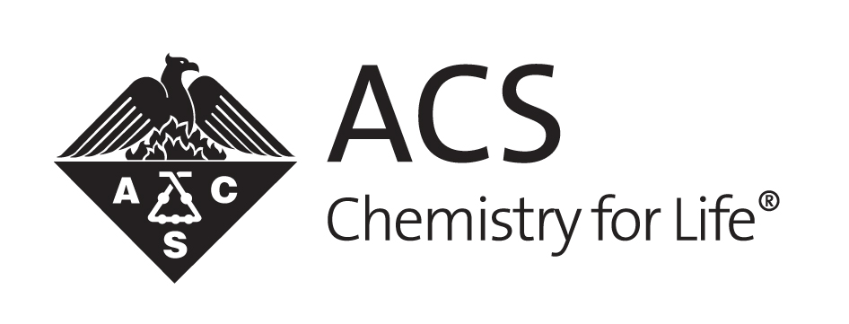
HUNGARIAN International Chemical Sciences Chapter 2012 Annual Report

Andras Guttman, President
3/22/2013

HUNGARIAN International Chemical Sciences Chapter 2012 Annual Report

DESCRIPTION OF CHAPTER:
ACS-HC, as part of a global organization, is a premier non-profit scientific society facilitating the interaction among industry and academic professionals in chemistry and related fields. ACS-HC promotes dissemination of chemistry and related fields to facilitate interfacing between the public and academia / industry, provides forums to address challenges in chemistry and related fields and utilizes the experience and networks of the chapter members coming from industry, academia, and regulatory bodies.
ACCOMPLISHMENTS:
- Attendance of at least one Board member or Board Delegate at the ACS national conferences to represent the Chapter.
- ACS-HU special session at the National Conference of Chemists in Hungary.
- Supporting organization for MSB 2013 in Charlottesville (VA), and HPLC 2012 Anaheim (CA) and ITP 2012 Baltimore (MD).
- Collaboration agreement was signed between the Hungarian Chemical Society (MKE) and ACS-HU on October 17, 2012 emphasizing the benefits of joint efforts to help Hungarian chemists inland and abroad.
- Memorandum of understanding was signed with the Hungarian Flow Chemistry Society on providing opportunity at its international meeting for awarding the Horvath Lectureship candidate.
- The Hungarian Flow Chemistry Society supported Andras Guttman for the IUPAC awarding committee for selecting the first awardee in Munich in 2012 (Klavs Jensen, MIT).
- International officer meeting of ACS-HU and ACS leadership, along with MKE in October 2012.
MEETINGS HELD DURING THE YEAR:
ACS-HU 2012Q2 meeting
Joint meeting with the Board members of the Hungarian Chemical Society (MKE) and ACS-HU (June 15, 2012; 14:00-15:00, MKE office). Present: Livia Sarkadi and Beata Androsits (representing MKE), Andras Guttman and Gyorgy Dorman (representing ACS-HU)

1. Joint efforts to increase membership: plan to establish a local chemistry group section at Graphisoft Park where at least 8 companies employ around 100 chemists.

2. Outlined the first draft of a general collaboration agreement between ACS-HU and the Hungarian Chemical Society (MKE).

3. Options were discussed to increase the involvement of small and medium size enterprises in both societies.

4. Support for young Hungarian chemists both in Hungary and abroad.

5. The effect of the Bologna Program on chemical education in Hungary.

6. The current declining situation of the Hungarian pharmaceutical industry and its effect on the migration of chemists.

7. Representation of novel chemical subfields by both societies.

8. Establishment of a nanotechnology subsection.

ACS-HU 2012Q3 meeting
SOTE, Nagyvarad Ter 18th floor meeting room (Sept 11, 2012; 18:00-19:00). Present: Ferenc Darvas, Eva Szoko, Gyorgy Dorman, Laszlo Lengyel and Andras Guttman. Absent: Tamas Kiss.

- Opening remarks and establishing quorum.

- ACS-HU representation at the ACS Fall IAC meeting in Philadelphia by Sandor Spisak (see short report under OTHER).

- Organization of ACS-HU board members to meet the new ACS president elect Marinda Li Wu and Bradley Miller (IAC of ACS) on the 9th of October during their visit in Hungary.

- Further intensify the relationship and collaborative efforts between ACS-HU and the Hungarian Chemical Society (MKE).

- Seeking support for the upcoming ACS-HU Horvath Lectureship.

- Problems with the organization of Biologics and Biosimilar analysis training in 2012 due to lack of funds and organizing committee commitment.

- Emerging Technologies Workshop to celebrate the 10 year anniversary of the establishment of the ACS-HU Chapter.

- Financials.

- Preparation for the election of the next ACS-HU president for the period of 2013- 2015.

ACS-HU 2012Q4 meeting
Joint meeting with the representatives from the Boards of ACS-HU and the Hungarian Chemical Society (Oct 17, 2012; 11:00-12:00, MKE office). Present: Ferenc Darvas and Andras Guttman (representing ACS-HU); Livia Sarkadi and Beata Androsits (representing MKE)

1. Organization of the local joint section at Graphisoft Park has been initiated.

2. Collaboration agreement was signed on efforts between the two societies on membership and joint events.

3. The Flow Chemistry Society is the first representing small and medium enterprises that started discussions with ACS-HU.

4. Suggestion to establish a curated/moderated blog site for both societies that could help young chemists to find new opportunities and peers for scientific discussions.

5. Joint training and short courses with MKE.

6. Involvement of the recipients of the new Momentum program of the Hungarian Academy of Sciences to increase visibility of the chapter.

7. ACS-HU to help young scientists finding scholarships and fellowships, such as the Fullbright and other options.

8. Joint efforts to deliver the Fabinyi award of the Hungarian Chemical Society at the 2013 ACS Fall meeting to Prof Somorjai.

ACS-HU BOARD MEETING AGENDA, 2013 Q1

Date and Location: March 22, 2013, 17:00-18:30, SOTE NET conference room, 18th floor, Budapest, Hungary. Participants: Ferenc Darvas, Eva Szoko, Tamas Kiss, Laszlo Lengyel, Gyorgy Dorman and Andras Guttman

- Opening remarks and establishing quorum.

- Discussion of the ACS-HU 2012 yearly report.

- ACS-HU representation at the ACS Spring IAC meeting in New Orleans. ACTION: Ildiko Kovacs, head of the young scientist section of ACS-HU, will represent the Chapter at the spring meeting. Preparation is on-going for the fall meeting when Dr Somorjai will be getting the Fabinyi award of the Hungarian Chemical Society.

- Continued intensification of the working relationship between ACS-HU and MKE. Membership issues. ACTION: Next executive meeting is planned on discussing joint efforts for the upcoming FROST conference in Budapest, the special Graphisoft section and about setting up a mutual cross-information blog site for ACS-HU and MKE members on international conferences where they attend.

- Seeking support for the 2012 ACS-HU Horvath Lectureship. ACTION: This lectureship will be given during the 2013 FROST conference in Budapest (Oktober 15-17). Suggestion for candidates have been solicited.

- Workshops and short courses organized by the ACS-HU Chapter. ACTION: Meeting organization support will requested from the Hungarian Academy of Sciences.

- Financials. ACTION: The board appointed Gyorgy Dorman to have full access to the accounts and arranging payments accordingly.

- Preparation for the election of the next ACS-HU president for the period of 2013- 2015. ACTION: personal recommendations are requested by the Board Members for the next Board meeting.

PHOTOGRAPHS OF EVENTS:
See enclosed file

OTHER:
The ACS-HU chapter was represented at the ACS International Activities Committee (IAC) meeting in the 2012 Fall conference in Philadelphia by Board Delegate Dr Sandor Spisak. He was first welcomed by Judy Benham who introduced him to Francisco Gomez and Bradly Miller. Dr Spisak attended the Subcommittee-2 meeting for Europe and the Middle East. The general discussion was about the goals of the IAC, including encouragement of collaborations, involvement of developing countries and maintaining human rights. In addition, it was emphasized that the momentum of IYC (International Year of Chemistry) should be kept after 2011. Another important topic was about the organizational details of the exchange student program and possible other help by ACS. An important emerging issue was the recent changes in publications, especially the open access forums jeopardizing the existence of major editorial companies and usual publication streams. Turkey was chosen to participate a 4 year experimental collaboration program with ACS.

PROJECTED ACTIVITIES FOR NEXT YEAR
- Supporting organization for the following international conferences: IMRET 2014, Green Chemistry 2013, Flow Chemistry 2013, MSB 2014.
- Joint organization of a special Chemistry Week together with the Hungarian Chemical Society to popularize chemistry.
- Participate at the Night of Researchers program in Hungary during the fall of 2013.
- Support the attendance and presentation of two young Hungarian chemists at upcoming ACS meetings.
- Participation at the Hungarian Chemistry Conference by a poster award that ACS-HU has established two years ago.
- Support for Attila Pavlath Chemistry popularization series by arranging translation of the material to other languages.
- Preparation of the Regulatory Conference and soliciting financial aid from the Hungarian Academy of Sciences.
- Addition of a special site to the ACS-HU webpage that lists PhD student grant and postdoc opportunities for young chemists including links to relevant sites of the ACS homepage.

CHAPTER OFFICERS AND CONTACT:
Dr. Andras Guttman (President) a.guttman@neu.edu
Dr. Ferenc Darvas (Past president) df.private@gmail.com
Dr. Eva Szoko (Vice president) eva.szoko@net.sote.hu
Dr. Tamas Kiss (Secretary) tkiss@chem.u-szeged.hu
Dr. Gyorgy Dorman (Treasurer) dorman@targetex.com
Laszlo Lengyel (Member) laszlo.lengyel@thalesnano.com
Dr. Attila Pavlath (Honorary president) attilapavlath@yahoo.com
Szilvia Gilmore (admin help) szilvia.gilmore@cominnex.com

